**21k3445 DB Lab 6 Connectivity**

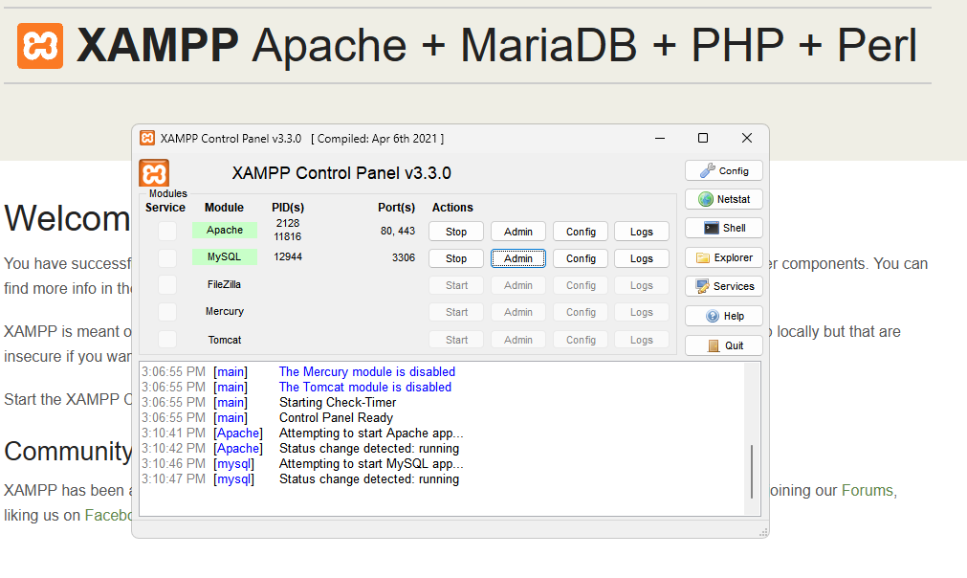

**Adding first Record**

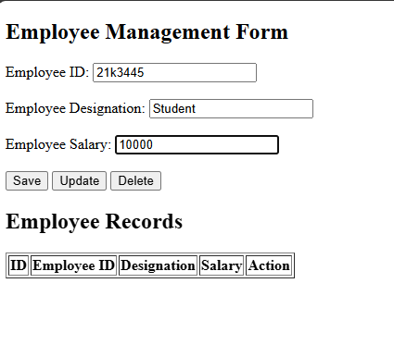

**After Clicking on Save**

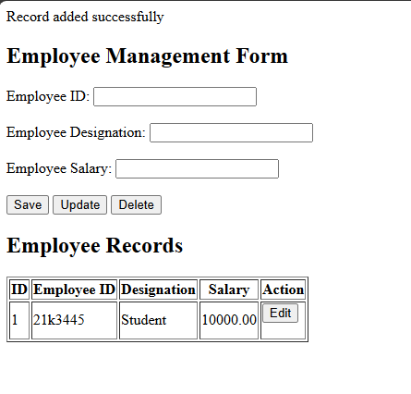

**Adding two more records**

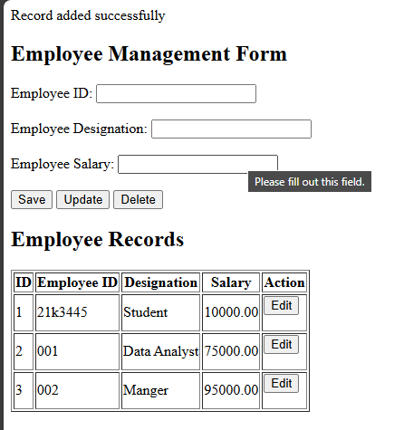

**Records Added in DB as well using form**

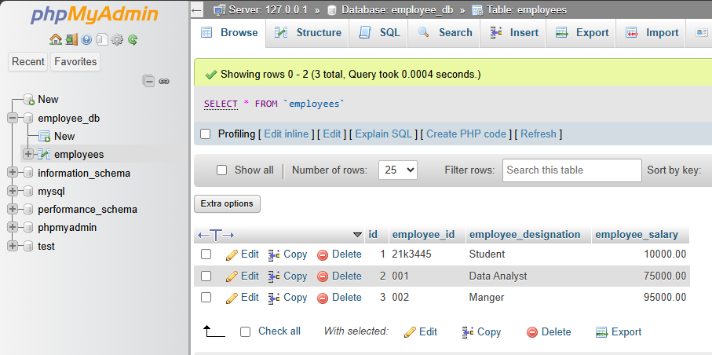

**Let's Try Updating using Employee id that we want to update**

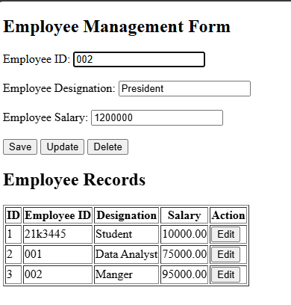

**Updated 002 id employee to President and 1200000**

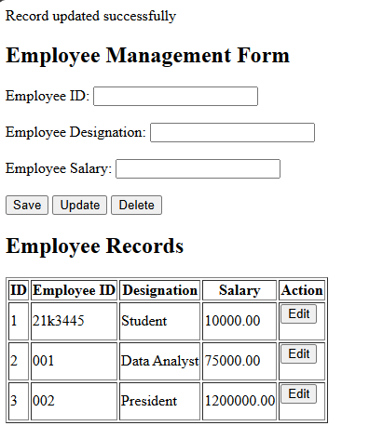

**Update Reflected in Database as well**

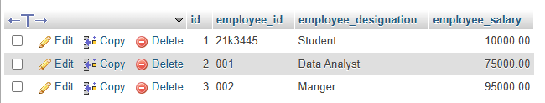

**Let's Try Deleting by providing Employee ID only**

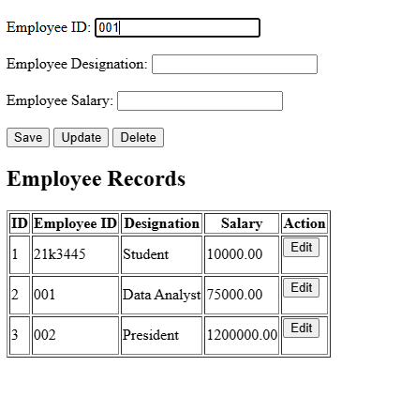

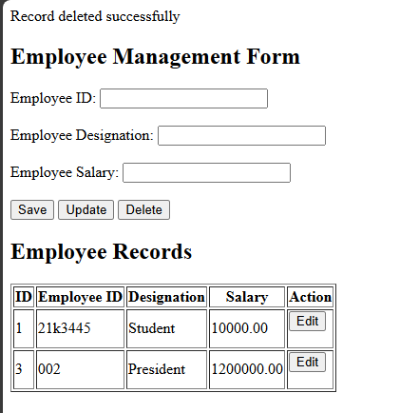

**Delete reflected in Database as well**

